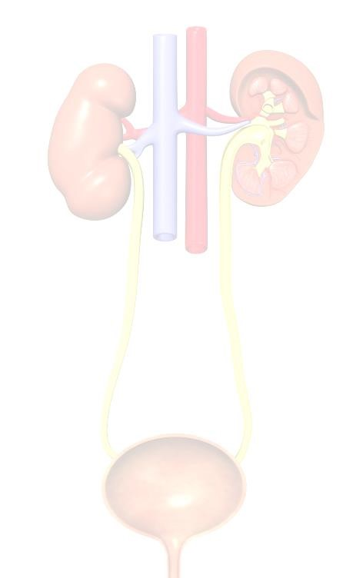

Advances in Urology Seminar 2023

Date:

4

th

February 2023

Venue:

Monash Medical Centre Clayton,

246

Clayton Road,

Clayton Vic 3168 (

Main Auditorium

)

Time:

0900

-

1300

hrs

**AGENDA**

**08**

**30**

**-**

**Registration**

**0900:**

**0900**

**-**

**0920:**

**Opening by Dr**

**Scott Donnellan (Director Monash Urology)**

**0930**

**-**

**Dr Madalena**

**0950:**

**Liu (Consultant urologist)**

**–**

**‘Bad apples, bad barrels or bad cellars**

**’**

**1000**

**-**

**1030:**

**BREAK**

**–**

**(**

**Morning Tea Sponsored by Boston**

**Scientific)**

**1030**

**-**

**Dr Weranja**

**1050:**

**Ranasinghe (Consultant urologist)**

**‘A Prostate cancer patient’s**

**journey at Monash Health’**

**1100**

**-**

**1120:**

**Dr Paul**

**Davies (Consultant urolog**

**ist)**

**-**

**Urethral Stricture**

**–**

**An overview!**

**1130**

**-**

**1150:**

**Dr Shekib Shahbaz**

**(**

**Consultant urologist**

**)**

**-**

**Robotic Surgery in Urology!**

**1200**

**-**

**1220:**

**Dr Kevin**

**Chu (Consultant urologist)**

**-**

**Bladder Cancer**

**–**

**An overview!**

**1230**

**-**

**1300**

**:**

**Interactive session**

**Register and pay online at: Advances in Urology Seminar 2023| trybooking Link:**

**https://www.trybooking.com/CDUEF**

**Monash Employee FREE of Charge**

**–**

**Promo Code: Monash**

**(**

**employee number required**

**)**

**Donation**

**welcome, Money will go to**

**purchasing Urodynamic machine for Casey Hospital.**

**NON**

**-**

**Monash**

**Health**

**Staff**

**-**

**$25**

**(**

**All proceed will go to purchasing Urodynamic machine for Casey**

**Hospital)**

**For further information**

**contact:**

**Indra**

**Jolayemi Tel: (03) 8768 1783**

**Mob:0407602384**

**|**

**Email:**

**indra.jolayemi@monashhealth.org**

**Certificate will be emailed on submission of seminar survey**

**(**

**No parking Reimbursement available**

**)**

